

Installation of WinPro/D FoxPro for version 8

From this version of WinPro/D, it will be necessary to install the program using sufficient administrative privileges for Windows.

If you use a Windows administrator account to install WinPro/D Foxpro onto the target machine, you are not concerned by the following information

Otherwise, an error message is now displayed in case you are not logged as Administrator when installing WinPro/D.

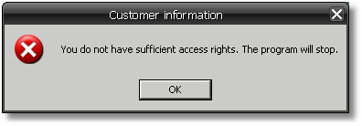

If you meet this dialog when running WinPro/D, you haven’t got enough installation privileges onto the machine !

If you already installed WinPro/D without an administrator account for the target machine, whatever the system is (XP, Vista or Seven…), proceed as follows :

- Use an Administrator level account for Windows. Please contact your computer supplier if you haven’t got those logon settings, otherwise installation is impossible.
- Install the package « Microsoft Visual C++ redistribuable » onto the machine. This package is supplied with any version of WinPro, and is named « vcredist.exe ». It is better to install the version supplied by Quadrature. The installation of this Microsoft package also requires administrative privileges onto the machine.
- Install the Sentinel dongle driver if required. It is available onto the base directory of our FTP server.
- WinPro/D may be launched at this stage. Nevertheless if you meet the below error dialog

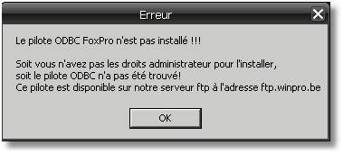

it will then be necessary to install the ODBC FoxPro VFP driver onto the machine, still using administrative privileges for Windows.
Indeed, some printings have been redesigned under WPReport module for WinPro/D, the ODBC FoxPro driver is then necessary to be able to print those.
You may easily find this driver onto our FTP server, or at url http://msdn.microsoft.com/en-us/vfoxpro/bb190233.aspx.
Some listing documents may be impossible to print without this driver installed onto the system.

We insist on the fact that if you install WinPro/D using sufficient administrative privileges onto the target machine, and when all needed components supplied are correctly located into the installation directory, all those processes are done automatically !

